Exploring Market Basket Analysis: Uncover Customer Shopping Patterns Across Multinational Market Using Apriori Algorithm

line 1: 1st Given Name Surname   
line 2: *dept. name of organization   
(of Affiliation)*  
line 3: *name of organization   
(of Affiliation)*line 4: City, Country  
line 5: email address or ORCID

line 1: 4th Given Name Surname  
line 2: *dept. name of organization*  
*(of Affiliation)*  
line 3: *name of organization   
(of Affiliation)*line 4: City, Country  
line 5: email address or ORCIDline 1: 2nd Given Name Surname  
line 2: *dept. name of organization   
(of Affiliation)*  
line 3: *name of organization   
(of Affiliation)*line 4: City, Country  
line 5: email address or ORCID

line 1: 5th Given Name Surname  
line 2: *dept. name of organization   
(of Affiliation)*  
line 3: *name of organization   
(of Affiliation)*line 4: City, Country  
line 5: email address or ORCIDline 1: 3rd Given Name Surname  
line 2: *dept. name of organization   
(of Affiliation)*  
line 3: *name of organization   
(of Affiliation)*line 4: City, Country  
line 5: email address or ORCID

line 1: 6th Given Name Surname  
line 2: *dept. name of organization   
(of Affiliation)*  
line 3: *name of organization   
(of Affiliation)*line 4: City, Country  
line 5: email address or ORCID

*Abstract*—

M

arket Basket Analysis helps find links and patterns in how customers shop. This advanced data mining method works best by using the Apriori Algorithm to discover hidden item patterns. The goal of this work is to use shopping list analysis on sales data from UK, Germany and France. This will help discover relationships between products. By using steps like support, confidence and lift, the Apriori algorithm can make association rules. These rules are guides that show connections between items or actions. It also tells us about things bought together, and the rules we get can help with setting up products for selling, maker plans for advertising sales, and managing what stuff we have. The results, shown by charts, scatter plot, interactive map and heat-maps, show how the Apriori process can find useful patterns hidden inside store data. By looking at what customers buy, we learn better how they shop. This shows that retail stores can make their business better and earn more money. We want to give a better understanding of buying habits by including information from transactions across countries too.

***Keywords—component, formatting, style, styling, insert (****key words****)***

# **Introduction**

Understanding what customers want and why they buy particular things is very important to businesses wanting staying power in today's retail world. This is where market basket analysis becomes indispensable. Market basket analysis is a detective's tool for retailers that helps them find the connections between products which consumers tend to buy together. This start is our opening into the world of Market Basket Analysis, specifically, how it can peel back the mystery around customer shopping habits and patterns.

The term Market Basket Analysis refers to the uncovering of relationships between products that are often chosen in combination. For retailers aiming to maximize the arrangement of products, design targeted marketing strategies or improve inventory control, this information is priceless. A well-known association rule mining technique is the Apriori algorithm, which we use to extract meaningful patterns from our transaction data.

The purpose of this project is to give an in-depth look at the use of Market Basket Analysis across different multi-national markets. We're not just a local project. Our Dataset includes over 38 countries. For this project, We will use item data from 3 countries. Thus, by employing the Apriori algorithm to uncover associations and then measuring their importance using support, confidence and lift metrics we hope for something like actionable insight.

Once the association rules are uncovered, we will analyze the item sets through different visualization techniques. Pie chart will be employed to visualize predicted item-sets on the basis of different metrics. First we will visualize the item set on the basis of the lift, confidence and support. Scatter plot will be used to display confidence, life and support of overall item set, per country. Heat-map will visualize item set based on per country.

In the contrary we have used the same structure in power-bi, we have showed the support basket, for the Market basket analysis. Confidence prod1 is used to show the, relationship of a certain products or item with other item in the data-set. This same is used to show case the relationship among other items as well and thus we found the confidence of the item, by making a pair. We also have showed cased this in the support basket.[1]

The next few sections will discuss the literature review, problem statement and methodology. Then we move on to in-depth examination of code implementation. The project ends in a complete examination of results and conclusions based on the found association rules. Through this exploration, we hope to illustrate the real-world applications of Market Basket Analysis in improving retail operations and making better business decisions.

The paper is organized as follows: In Section II, we look at the Literature Review wherein we give a summary of the evolution of Market Basket Analysis, fundamental aspects of association rule mining, its use across various industries and the issues and advancements in the field. Section III allows highlighting the problem statement. It focuses on the complex nature of interpretation of consumer preferences from the available large retail datasets and emphases the need for taking advantage of the Market Basket Analysis to come up with practical recommendations. After this part, section IV is done which is the Methodology in which we describe the data collection, cleaning, transformation and analysis processes including the Apriori algorithm implementation and visualization methods. More so, the use of Power BI Dashboard will be covered which is designed to facilitate and enhance the data consumption. In Section V, Results are presented, which in turn represent the findings from the Market Basket Analysis on the UK retail dataset. Finally, in Section VI, The Conclusion is the part which summarizes the main lessons learned from Market Basket Analysis directing to its practice by retail store owners and making strategic decisions. Emphasizing this structured method, we will demonstrate how Market Basket Analysis improves retail operations and supports business decision-making processes by extracting the practical aspects of it.

# **Literature Review**

Market Basket Analysis has become a powerful weapon in the commercial world, enabling companies to discover non-obvious mutual relationships among a wide range of products. Its origination is linked to the research of early economics and business information management, in which scholars and practitioners were directed to study people’s behaviors as well as selling patterns. Conversely, the development of connection rule methods was what really pushed Market Basket Analysis into the spotlight. These methods which came into existence, have become the backbone of the field because of their ability of grouping by common items in many occasions of transaction. This review aims to explore the evolution of Market Basket Analysis, highlighting the basic concepts, historical background, and modern approaches of the technique. We will discuss the core points, the way they got influenced by the historical shifts, and also describe the top-notch techniques within the sphere of Market Basket Analysis to provide a detailed look into the important instrument utilized by businesses operating in the current dynamic economic environment. By this process, we try to uncover the long-standing applicability of Market Basket Analysis and incorporate new techniques in the modern world of commerce.

## Historical Evolution of Market Basket Analysis

This para will provide a brief overview of how the approach to baskvet analysis in markets has changed over time. For checking out what customers buy, market people studied their actions by seeing which items are bought together. We can use this to find out where Market Basket Analysis was first created. Ever since Agrawal et al. wrote about the Apriori algorithm in 1993, this change from studying by hand to quick thinking has become very strong. Apriori broke new ground. This tool was able to fast find out connections between big shopping data. It allowed stores to see consumer habits easily. [1]

## Foundational Concepts in Association Rule Mining

The basis of Market Basket Analysis is association rule mining, which generates rules to show the relationship between things in a transaction. The fundamental metrics guiding association rules include:

Support: Shows how often a rule is seen in the data set. Stronger connections show values more aligned with 1.0.

Confidence: A way of checking how dependable a rule is: this means, how likely is it that if one thing happens then another will too? Yes, and all these factors added together help to better understand and predict what might happen in the future. [1]

Lift: It shows how important something is when another thing happens with it, while considering its likely chance of happening.

## **Applications of Market Basket Analysis**

Beyond retail outlets, its applications to the diverse industries in healthcare, telecommunications, and e-commerce platforms are not to be underestimated. Besides only finding the product association, Market Basket Analysis does also hold the power of taking place in the strategic decisions of several sectors. In healthcare, for instance, it has been applied to finding possible correlations between treatments and patient outcomes. This, in turn positive outcomes of evidence-based medicine and patient care. In a similar sense, cell service companies use Market Basket Analysis to optimize their services and develop the individualized plans to address the needs of different client bases. In the e-commerce, where Market Basket Analysis guides on merchandizing and product placements and helps in creating a personalized shopping experience, the site visitors can enjoy the efficient way of buying. For online businesses, the website becomes one of the tools to gain the highest revenue. Eventually, Market Basket Analysis can be named as the main analytical instrument for companies which helps create efficient processes, ensure satisfied customers, and let the managers make educated decision about every level of business.. [2]

## Challenges and Advancements

While market basket analysis has successfully identified areas of opportunity, challenges remain on managing the volumes of data, improving algorithm performance and setting the privacy parameters right. Addressing these obstacles means continuous research, that centers on developing the use of cutting-edge computing methods and integrating artificial intelligence (AI) and machine learning (ML) models. Under the amplification of AI and ML, Market Basket Analysis can elevate the scope of its insights and gain more accurate and bigger insights on market behavior and product associations. Artificial intelligence smart algorithms and data processing techniques enable the thorough and quick analysis of a vast volume of data, which makes it possible to achieve faster decision-making, operations, and, therefore, improved efficiency of business. Moreover, the leveraging of AI and ML will give rise to sophisticated predicting techniques in Market Basket Analysis that would entail organizations to forecast consumer preferences and market trends more accurately. While these technologies continue to develop, we need to be aware of privacy constraints and ethical concerns, with a view of keeping Market Basket Analysis useful and helpful both for the business as well as for the consumers.. [2]

## Cross-Cultural Considerations

In the global market, cultural factors become a major influencing factor for the consumer preferences and behavior development. The size of population and the geographical location of a certain region, in addition, will shape the markets and the patterns of demand respectively. Hence, a thorough review of information should be undertaken to serve the purpose of establishing consumer behavior and retail sales patterns cross diverse regions e.g. Germany, UK and France by Market Basket Analysis. This analysis helps to get adept knowledge of evolving consumer tastes, buying habits and specific image of each product. Through assessing the development of Market Basket Analysis in this regions along with the unchanging cultural and economic factors, we can design marketing strategies, product placement, and inventory management which is suitable to the needs of the consumers in each market. Furthermore, understanding such trends helps businesses to promote their existing offerings and services effectively, which determines their competitiveness and success on the global level.. [2]

# **Problem statement**

Interpreting consumer preferences from large retail datasets is a difficulty. The use of Market Basket Analysis on transaction data from Germany, the UK, and France is necessary because traditional methods are insufficient. Establishing product relationships, maximising placement, creating marketing plans, and reducing inventory waste are the objectives. To improve overall retail operations based on client preferences, the challenge is to derive actionable rules from big datasets.

# **Methodology**

The dataset was acquired from kaggle, the dataset contains retail transactions based on each country. Our dataset contains 38 countries retail transactions.

### **Data Collection**

This dataset contains details about each transaction such as Invoice Number, Stock Code, Product Description, Quantity, Invoice Date, Unit Price, Customer ID, and the Country of the transaction.

### **Data Cleaning**

Having the integrity of the data is an absolute must for any data analytical project to be effective. In the beginning phase, the data cleaning and the preparation phase that involves eliminating all the inaccurate and inconsistent data as well as data with any distortions or bias are undertaken. Following are the critical procedural steps:

* Trimming Description Spaces: This is one of the steps that consists of the elimination of spaces, either before or after the product description. Furthermore, normalization removes unneeded spaces which then guarantees that product descriptions have the same format which is then accurate across the entire dataset. Through deleting unnecessary, non-demanding spaces, the dataset is extracted and standardized, which makes it clear and easier for analysis, analysis and interpretation.
* Duplicate Invoice Removal: Entries of duplicate invoices are capable of generating anomalies in data analysis and eventually, wrong information. Hence, the identification and removal of double invoices from the data set will be crucial to achieve this. The duplicate removal approach is guaranteeing that all activities are presented once, avoiding the created of irrelevant events and providing accurate understandings of purchasing behavior.
* Invoice Type Standardization: By standardizing the 'string output' data type for the 'InvoiceNo', it helps to achieve consistency and evenness in the data handling. While changing the 'InvoiceNo' type to a string presumes that invoice numbers are formatted in the identical way even if they are completely different right from the start. This standardization helps to make offline transactions much easier to process and analyze, even for complex operations.
* Cancellation Transactions Exclusion: Transactions labeled as 'C' are to be discarded and shouldn't come into play with the analysis for the sake of preciseness and certainty of the findings. The deletion of the void transactions ensures that the analysis is only done on the purchases that were completed, and not on the transactions that were voided, making the insights based on relevant and genuine data.
* Column Pruning: Column such as 'StockCode' and 'InvoiceDate' which seems to be redundant and unnecessary are removed from the dataset, consequently streamline and simplify the data structure. Dropping redundant columns not only simplifies the complexity of the dataset storing, but also enhances the organized analyzing process as well. The processing of hiding unused columns in the dataset will do well to improve the output by increasing efficiency and effectiveness.

In general, these data cleansing steps are very valuable for data preparation which ensures accuracy, consistency, cleanliness and any unintentional biases are removed from the data. Visible cleaning and refining the data researchers in term of production of valid insights and decision based on accurate data.

### **Data Transformation**

With a cleansed dataset in hand, the focus shifts to transforming it into a suitable format for Market basket analysis. This involves creating a transactional matrix where each row represents an invoice, each column represents a product, and the cell values indicate the quantity of each product in a specific invoice. The transformation process includes:

* **Grouping by Country:** Separating data for each country to allow for focused analysis.
* **Summing Product Quantities:** Aggregating product quantities for each invoice to capture purchasing patterns.
* **Handling Missing Values:** Filling in missing values with zeros to maintain the integrity of the transactional matrix.
* **Encoding Data:** Converting all positive values to 1 and non-positive values to 0, simplifying the dataset for analysis.
* **Removing 'POSTAGE':** Eliminating the 'POSTAGE' item from the analysis to focus on tangible product associations.
* **Filtering for Relevant Invoices:** Selecting only those invoices with two or more items to accentuate meaningful purchasing patterns.

### **Apriori Algorithm and Association Rules**

The Apriori algorithm represents the classical way in data mining to find frequent item sets and to generate association rules from the transactional data. This is based on the "Apriori property," which is a principle that states that for a set to be frequent, as sets we should also be frequent. The presence of this characteristic helps FP-Growth algorithm to effectively discover frequent item sets as it progressively detects and disregards the potential pattern sets that do not satisfy a predefined minimal support criterion. The Apriori algorithm in the sense that firstly it percentages the individual items to be the candidate item sets of length one that are purely based on the transactions available in the dataset. Correspondingly, it runs across the data set and counts the presence of every pool of each candidate item set and thereby computes the support number (frequency of occurrence). Supports lower than a minimum are not held for from the next dealings. Moreover, the algorithm develops new item sets of the increased length thanks to combining the pairs of the frequent item sets from the previous iteration. The algorithm goes through this process repeatedly until no new frequent item sets can be found. In the end, from frequent item set, associative rules are derived which depict the relationships among items and shed light on the hidden valuable patterns in the data. The Apriori algorithm is primarily used for market basket analysis where the algorithm detects and measures frequent products purchases and gives suggestion to the retailers about cross-selling. These solutions are being utilized in different fields of application e.g. recommendations, web usage mining and genetics. Within the context of the project, the Apriori algorithm represents a highly suitable tool for analyzing retail transactions in different countries to position the product properly, design tailored marketing strategies, and ensure some stock control. Its good performance in handling large datasets of transactions and identifying important relationships between items makes it a perfect fit for the project’s goals.

We have our ready list of data. Then, we use the Apriori method to find what items show up most often together in UK, France and Germany. This helps us work out connections between these things in a detailed way. Putting a low help limit at 0.03 makes sure that we look for big groups of things. Rules are made based on the lift score, a measurement of how much more likely one product is to be bought when another is purchased. The final rules get lined up in reverse order, from highest to lowest. Then they're ready for more studying..

### **Visualization**

To enhance our understanding and interpret the pattern relationships within the dataset, we use various visualization techniques. In Python, we create compelling visualizations, including Bar Chart, Pie chart, heat-map and 3D scatter plots, to illustrate the association rules in terms of lift, support, and confidence. The visualization is done for each country separately. Predicted Analysis is done through visualization to display the frequent patterns based on various metrics.

### **Power BI Dashboard**

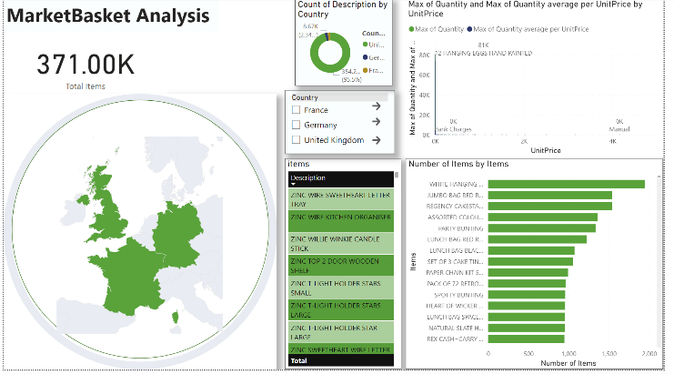

This user-friendly interface has maps that show items and associations in stores across three countries. It also has interactive map, the prices of individual items, and details about all the transactions. The UI on Power BI is the main place to see data in pictures and numbers. It shows us more about how people in Germany, United Kingdom and France buy things all put together better. Our board focuses on giving users a good experience. It does this with a nice look and easy ways to get around. People can easily change between parts of the information, learning something. The tool we use, called a dashboard, includes maps. These maps help us understand where retail things are bought in three different nations. They show how products are spread out over the countries. With better analysis, we give businesses future guesses and plans. This allows companies to change their ways as markets shift. Moreover, users can find out how much a product costs and it's result. This can give them a money lesson.

# **Result**

The dataset was acquired from kaggle, the dataset contains retail transactions based on each country. Our dataset contains 38 countries retail transactions.

### **UK Basket**

Fig 1.1

Top Five Generated Rules

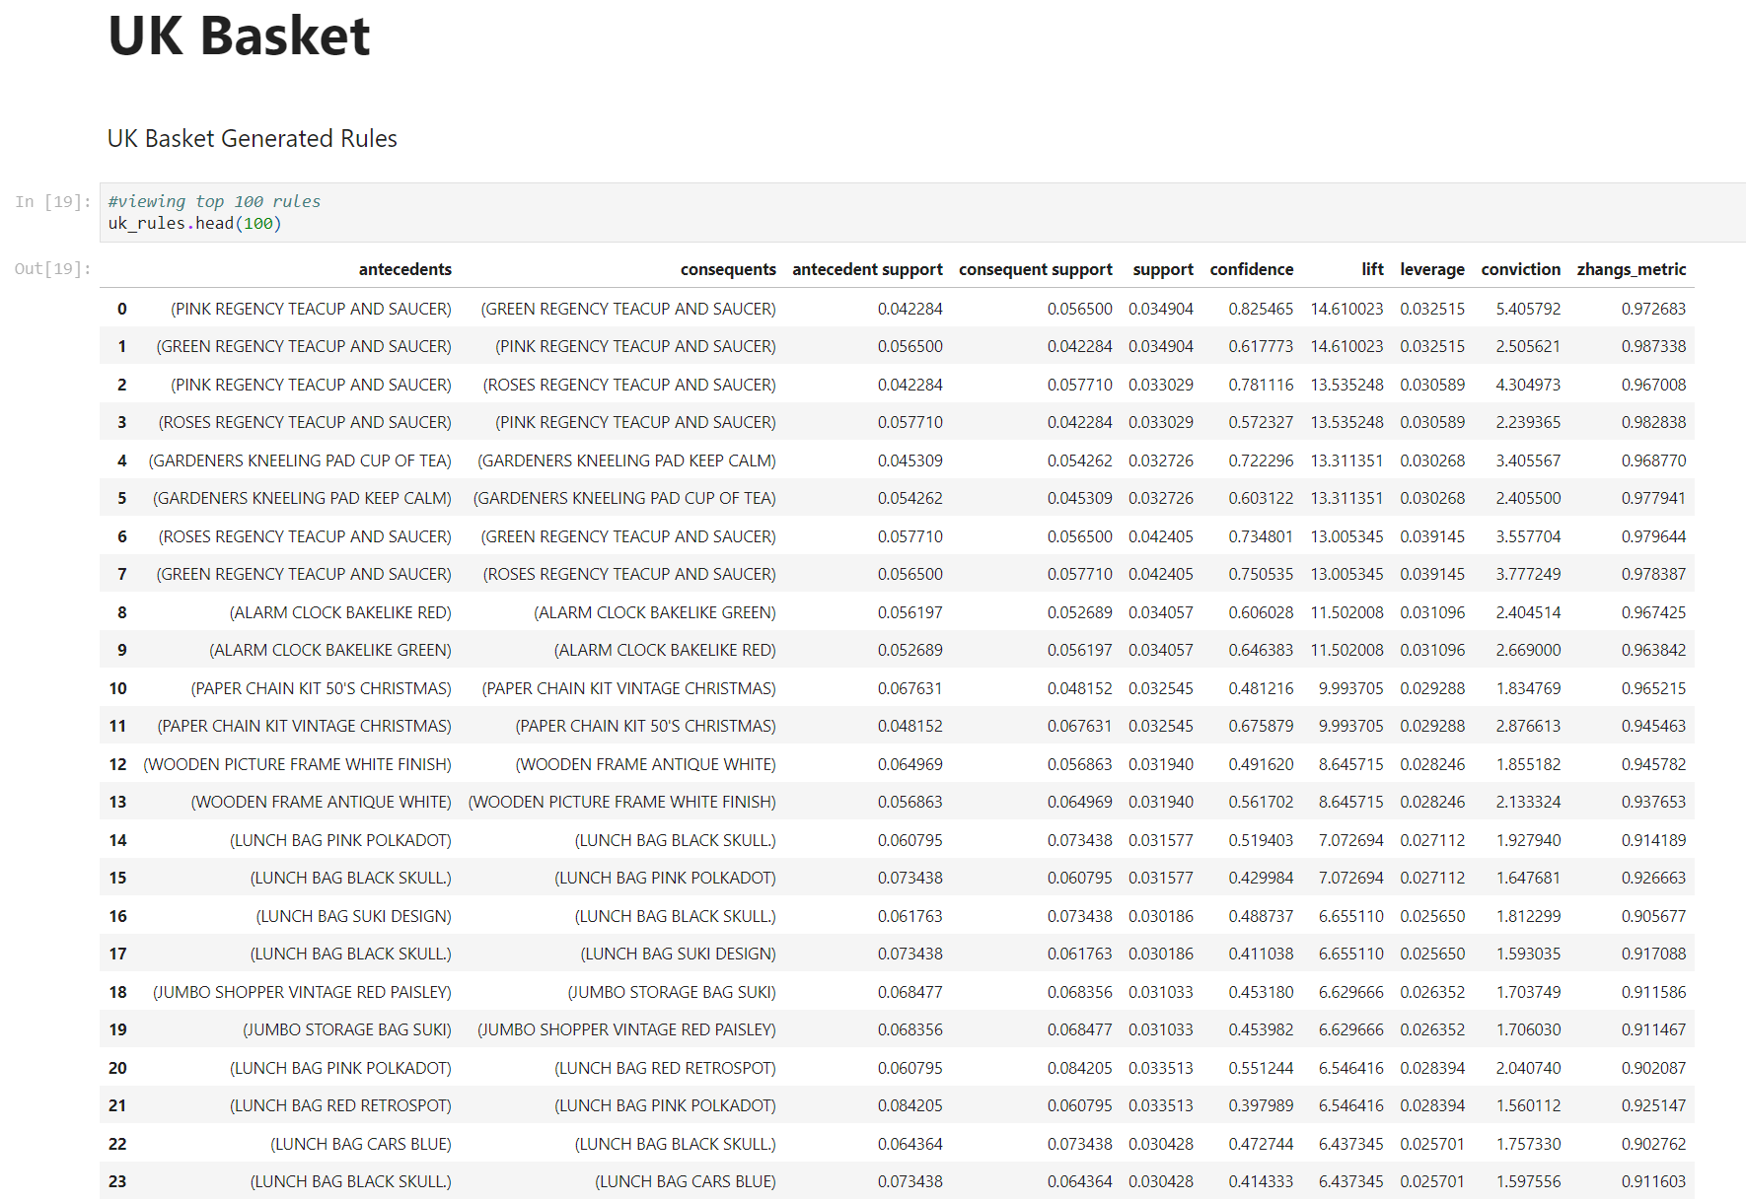

Fig 1.2

Top Five Generated Rules By confidence



### **Germany Basket**

Fig 2.1

Top Five Generated Rules

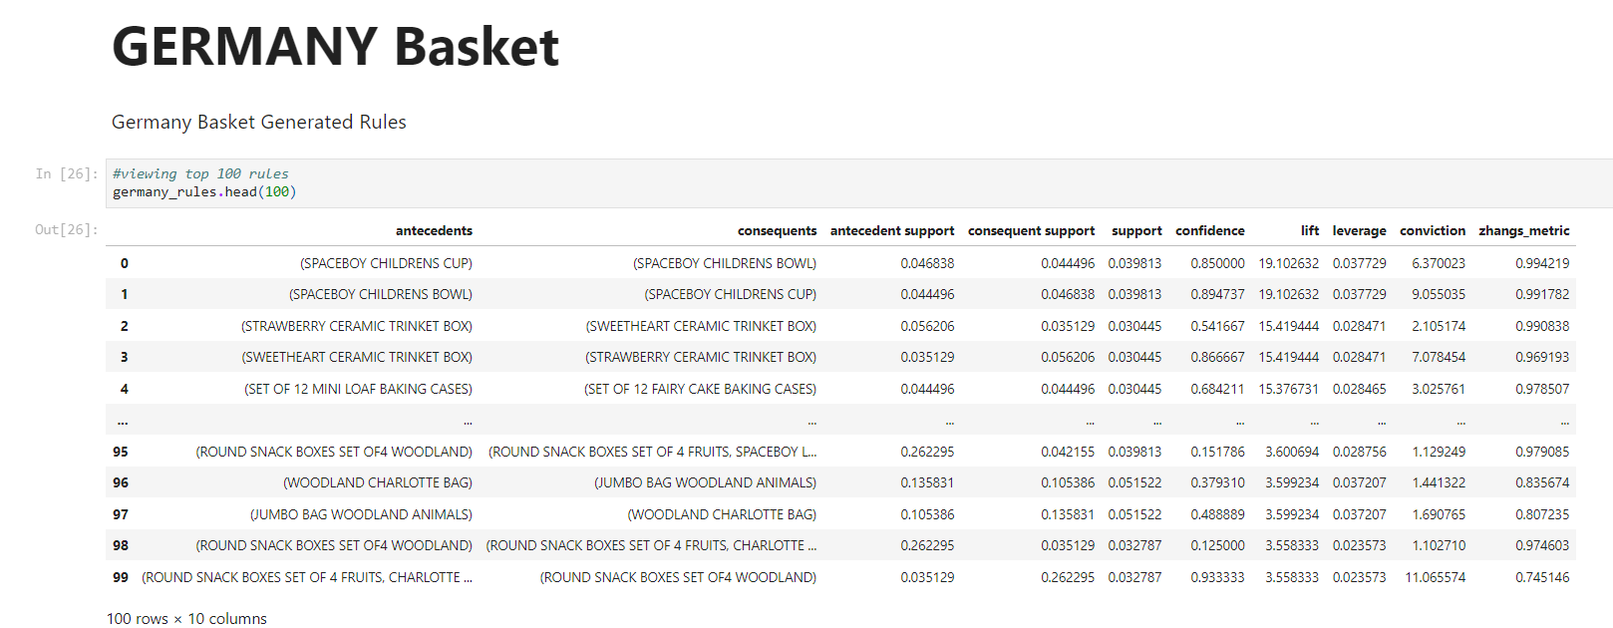

Fig 2.2

Top Five Generated Rules by confidence

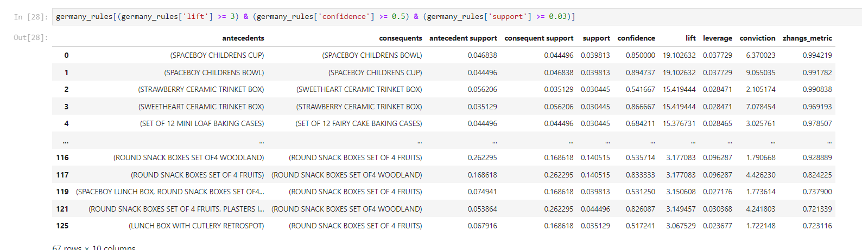

### **France Basket**

Fig 3.1

Top Five Generated Rules

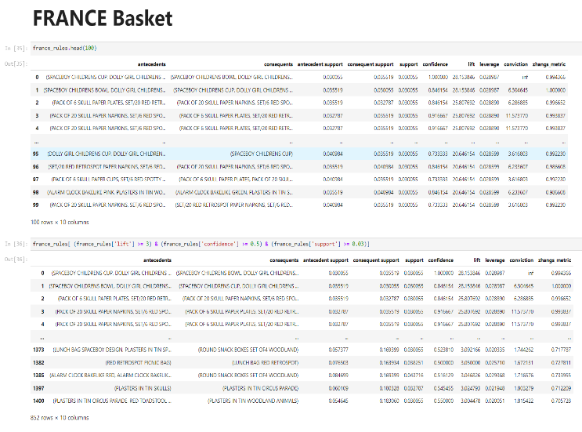

Fig 3.2

Top Five Generated Rules by confidence



# **Conclusion**

The application of Market basket analysis using Apriori algorithm on our retail data-set provided us an extensive look into item patterns and user buying habits. By going hands-on with exploratory data analysis, generating association rules, and adding a visualization through Python and Power-BI dashboard, we've gained some detailed insights into how customers purchase items and which items are purchased frequently. The findings from the retail data from the United Kingdom, Germany and France has practical benefits for retail stores. These rules can serve as a comprehensive guide for retail businesses, help them in strategic decision-making. Businesses can now stock their shelves with accuracy, ensuring popular products are readily available and what customers really want. The visualization depicts the findings in a user-friendly way and enhances the project depiction.

# **References**

1. <https://dl.acm.org/doi/10.1145/170036.170072>
2. <https://rakesh.agrawal-family.com/papers/sigmod93assoc.pdf>
3. https://www.sciencedirect.com/science/article/abs/pii/S0167923604000685

# **Appendix**

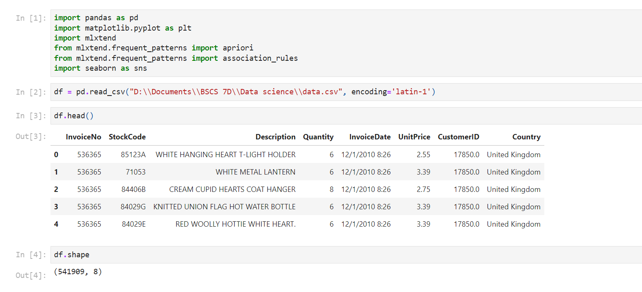

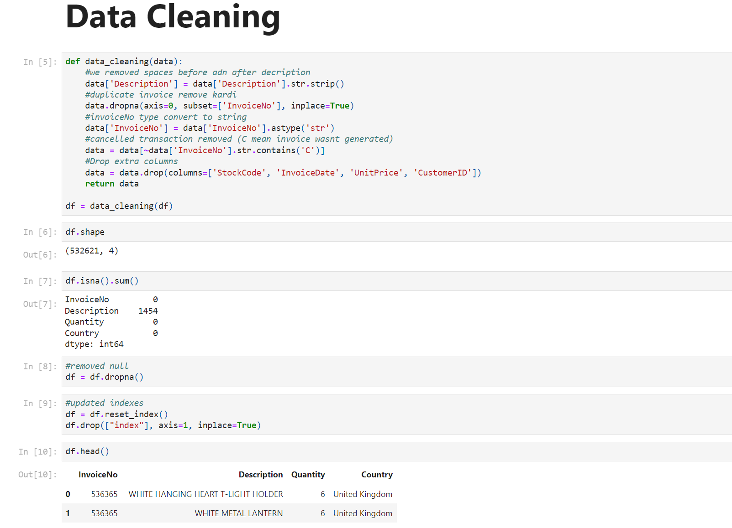

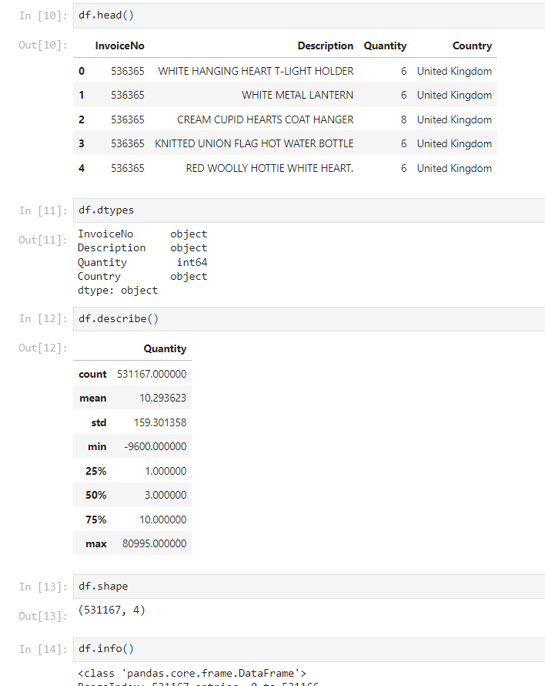

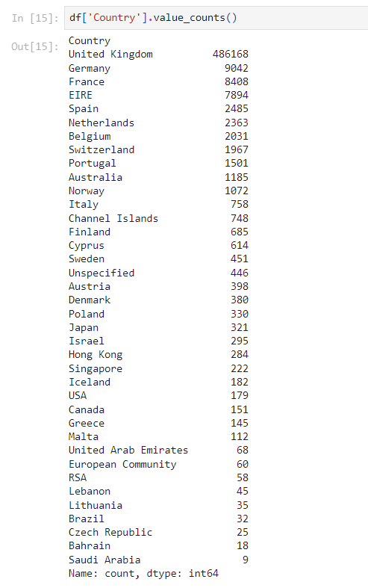

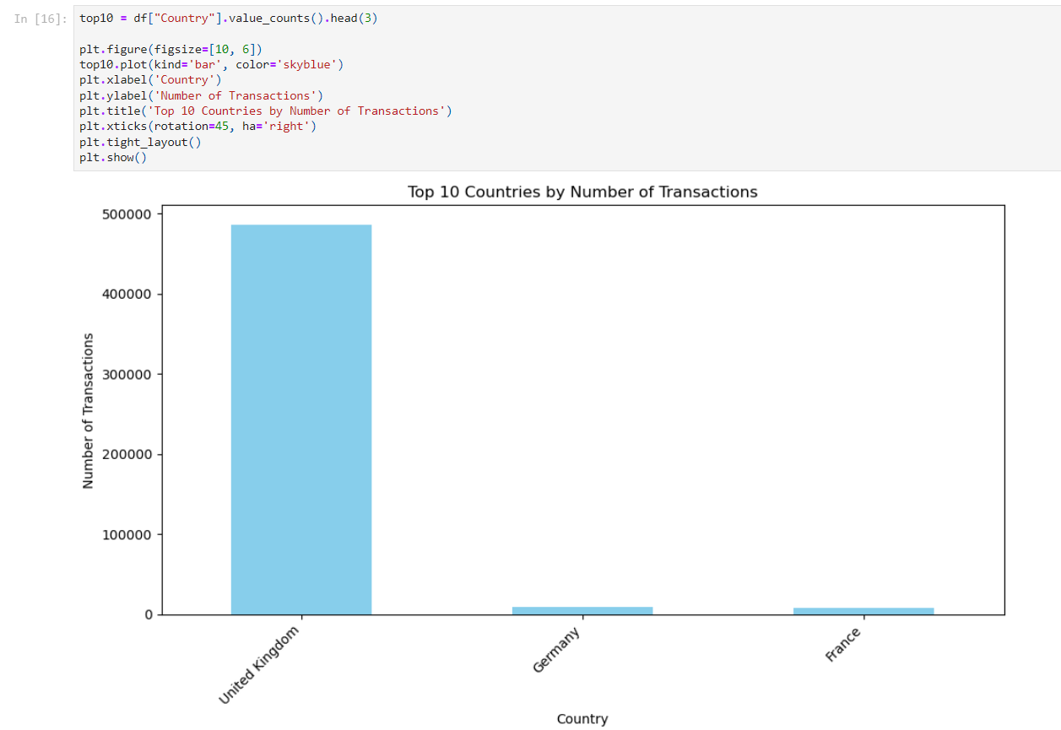

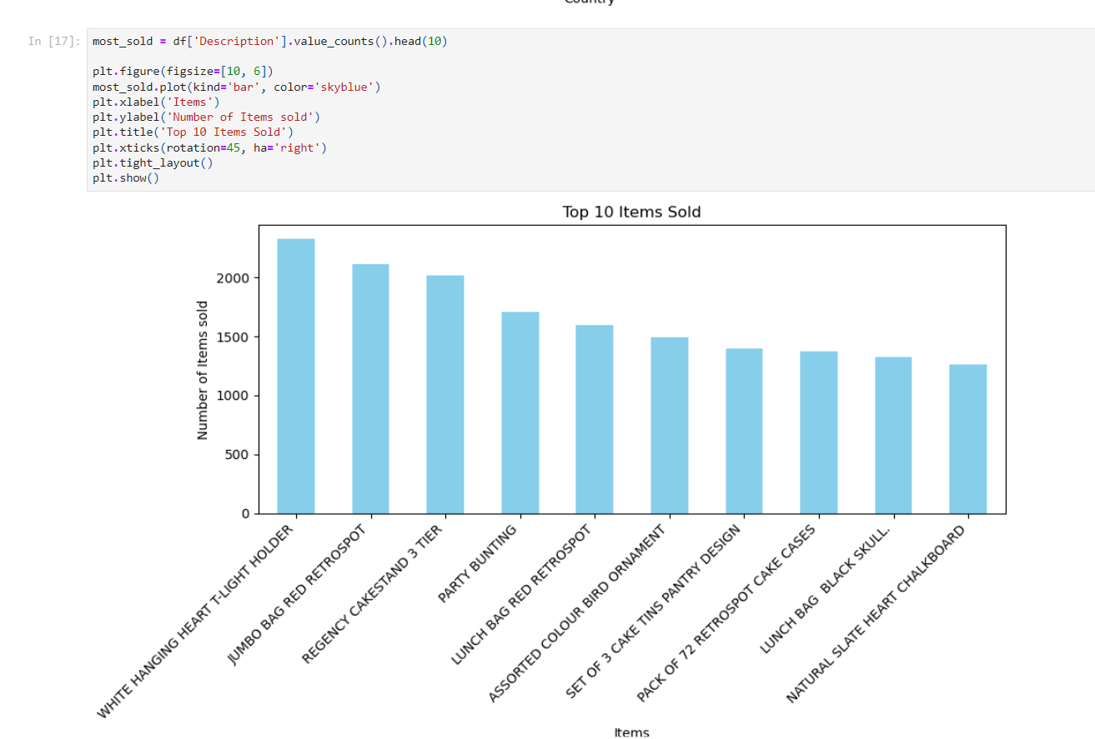

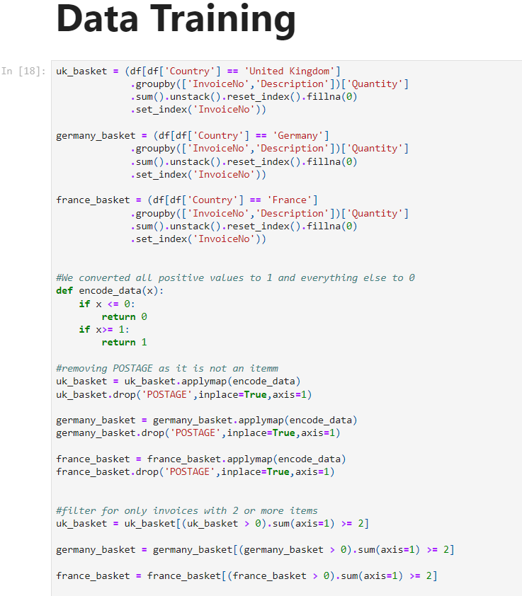

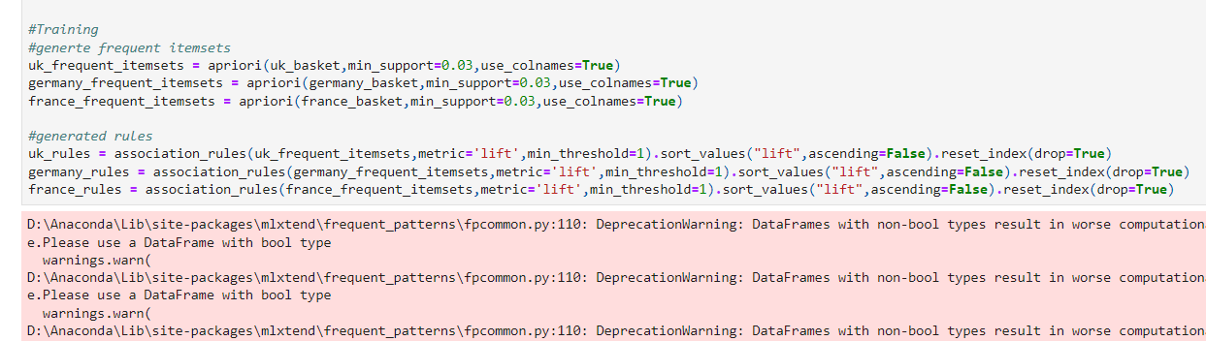



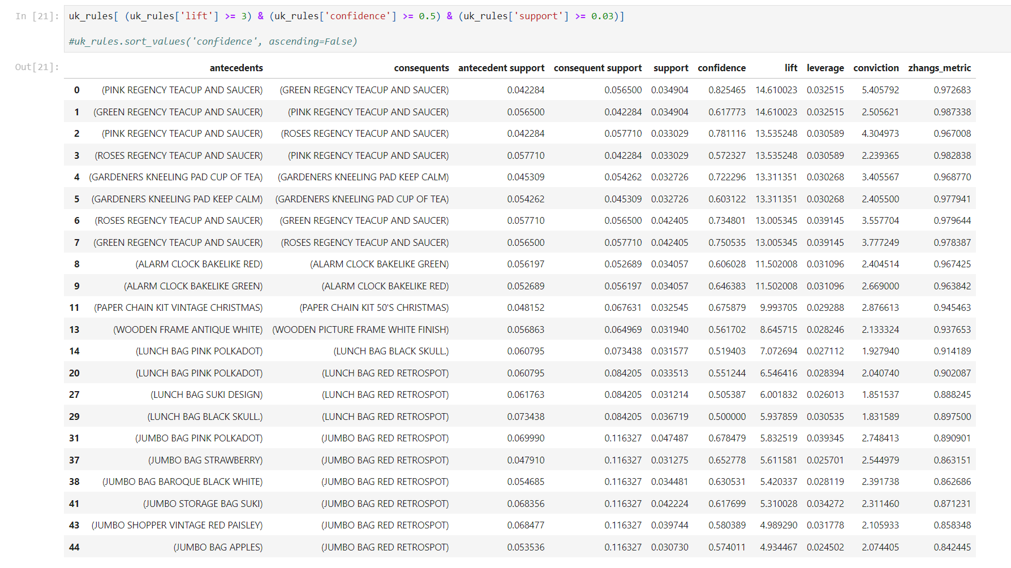

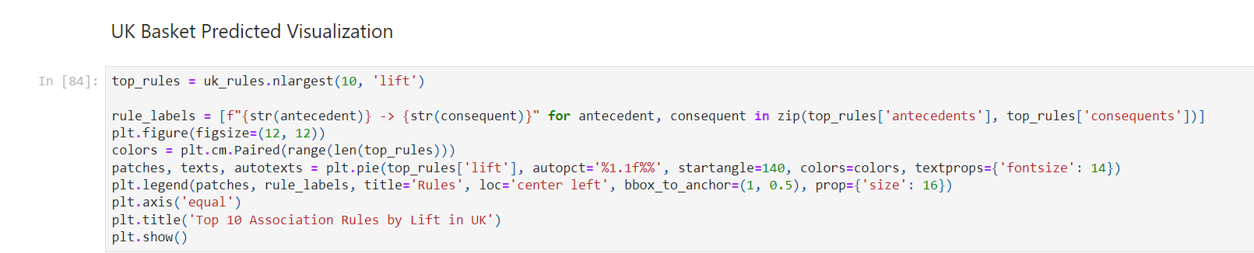

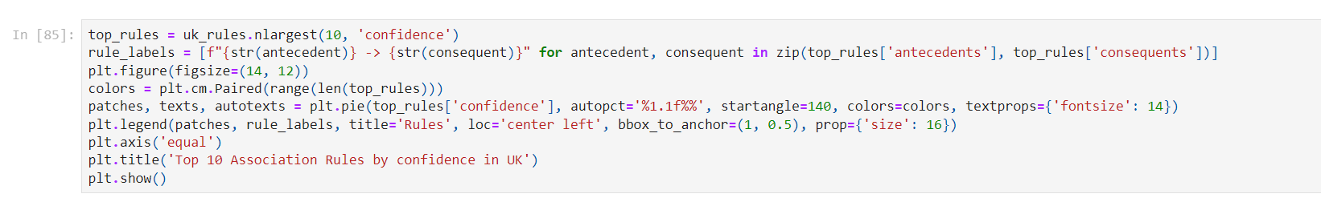

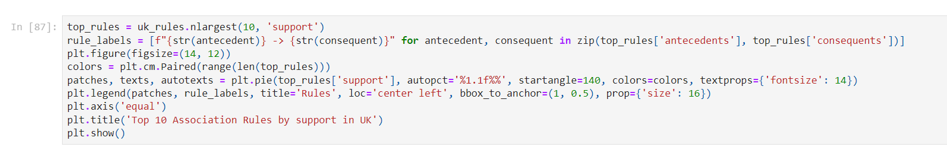

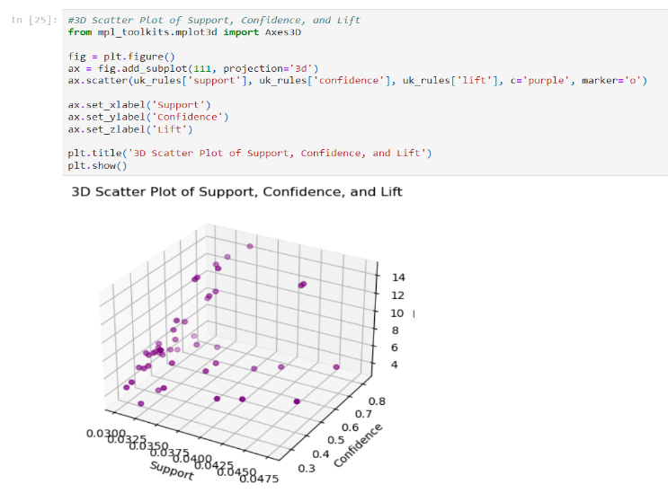

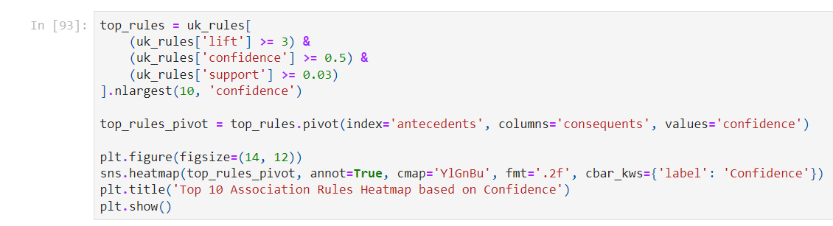





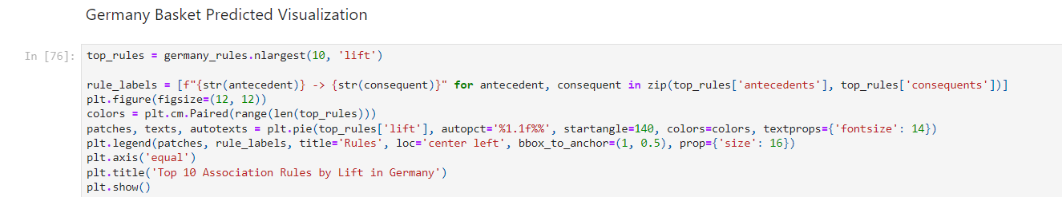

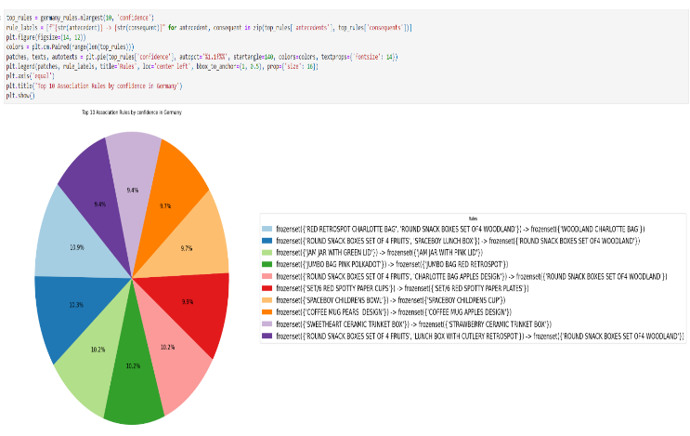

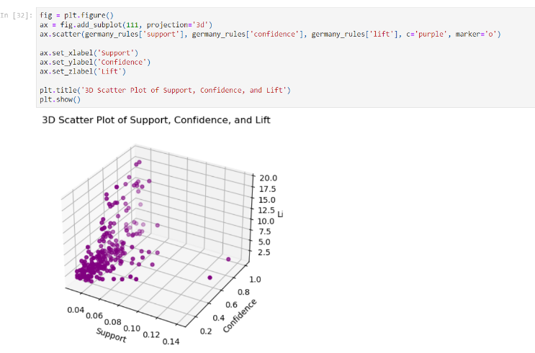

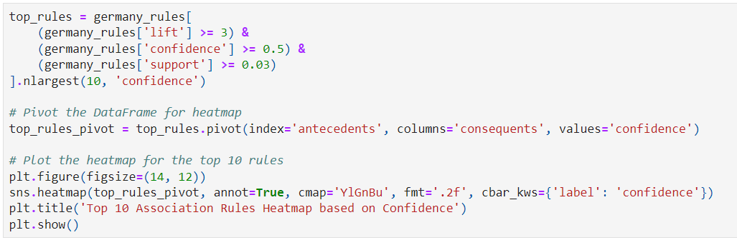

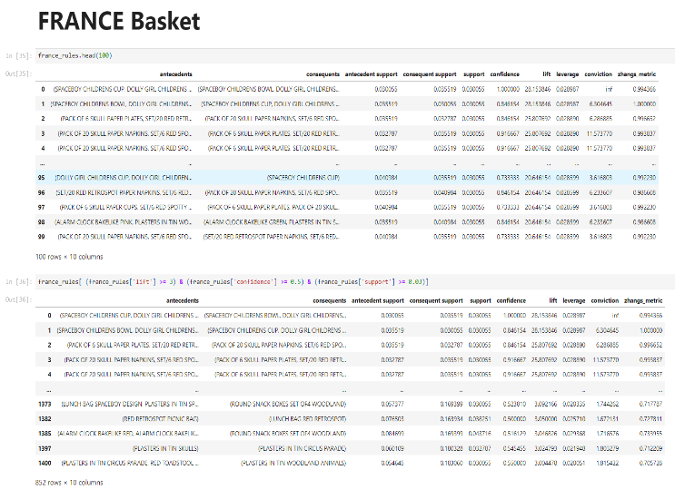

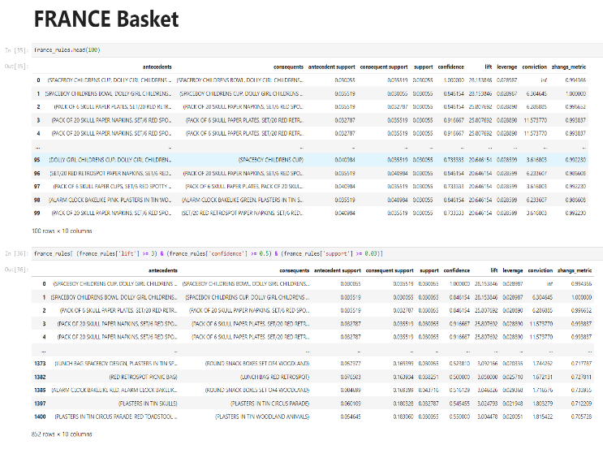

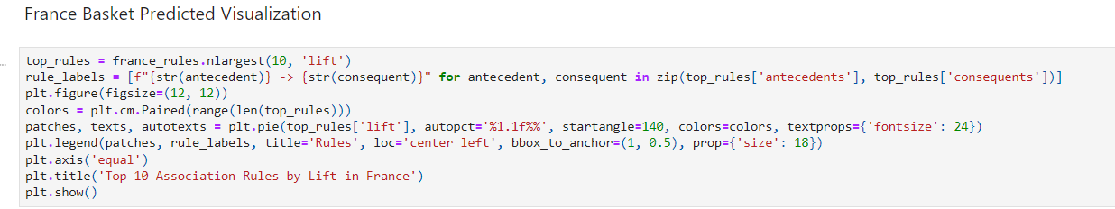

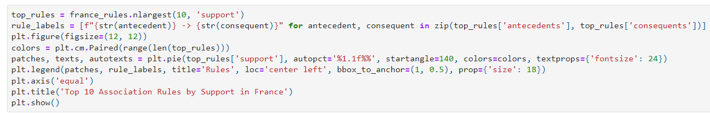

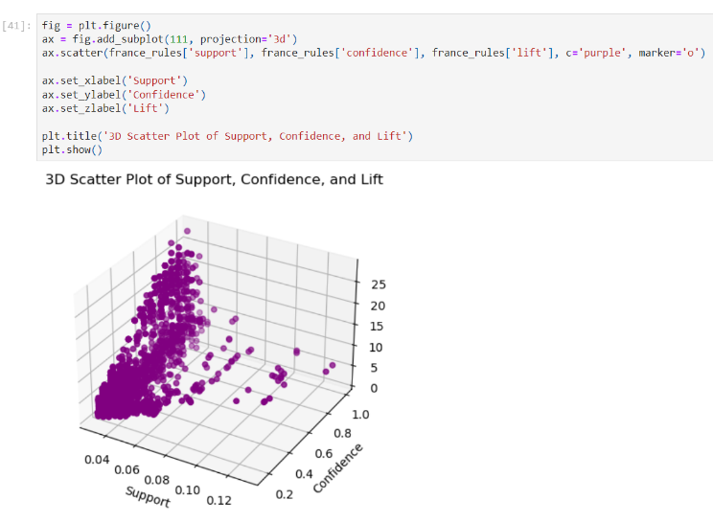

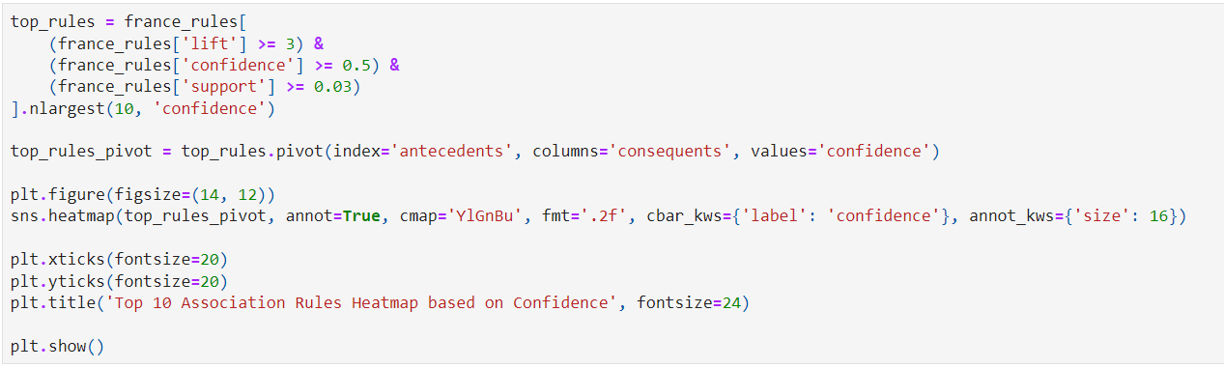

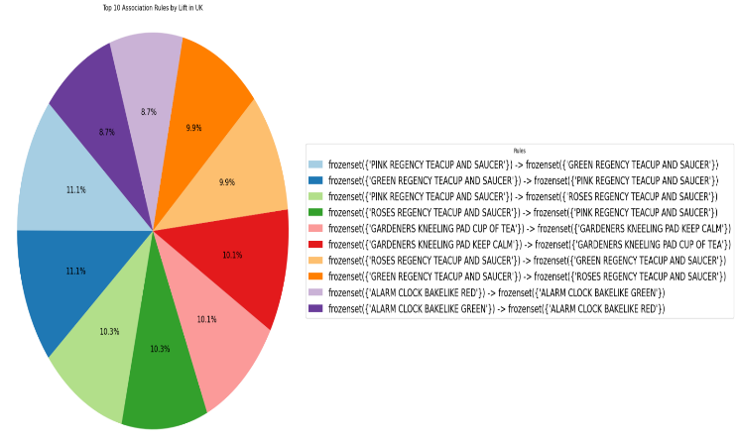

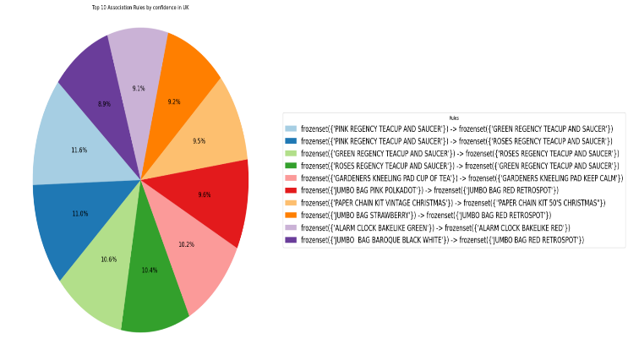



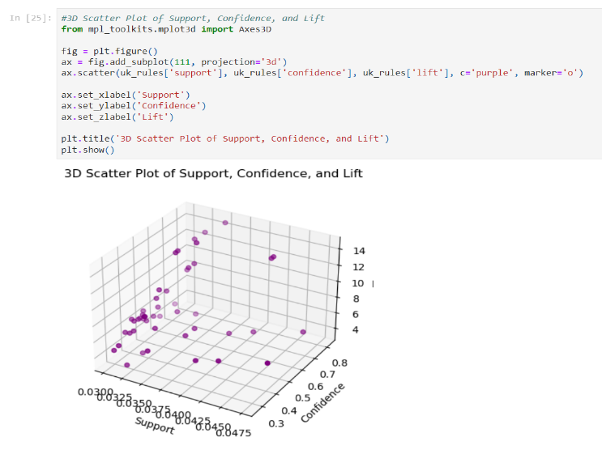

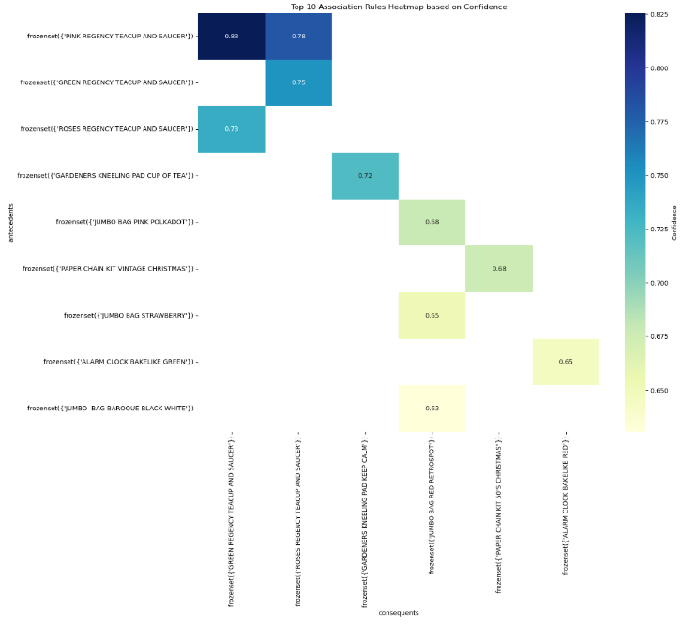

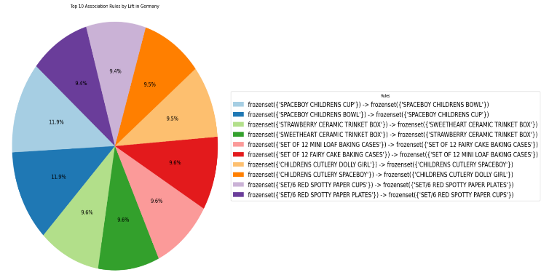





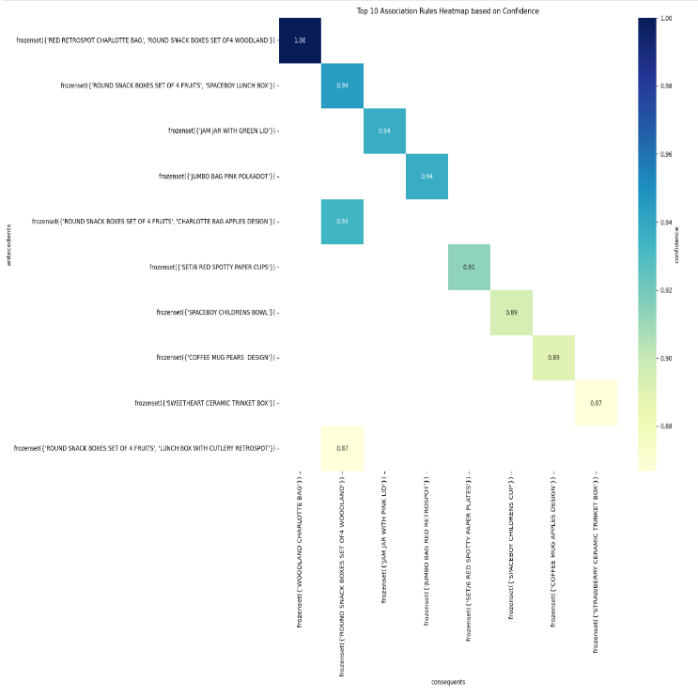

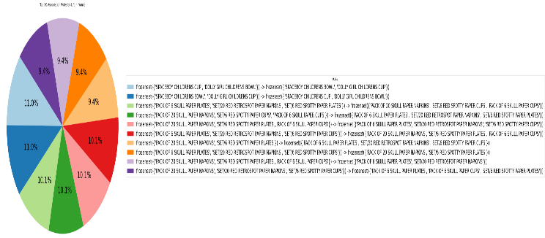

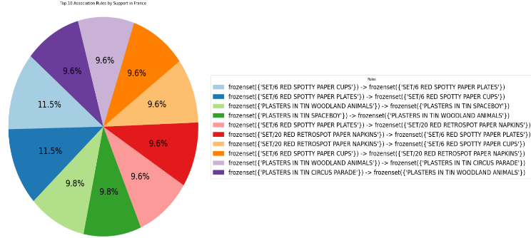

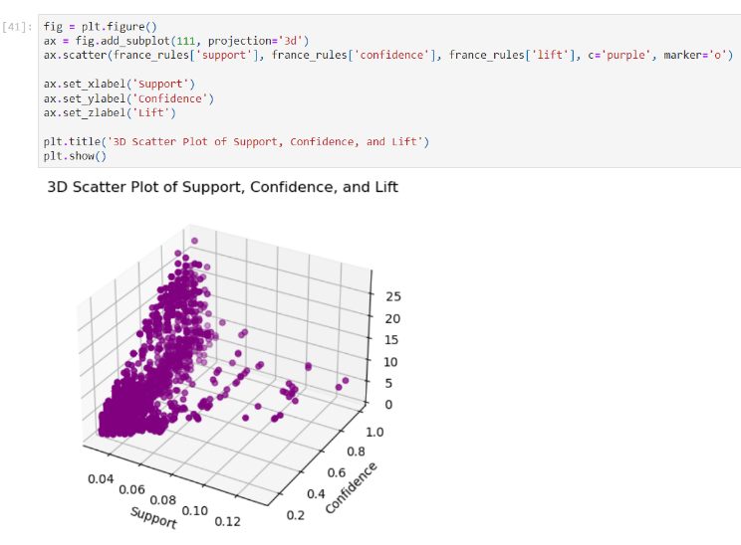

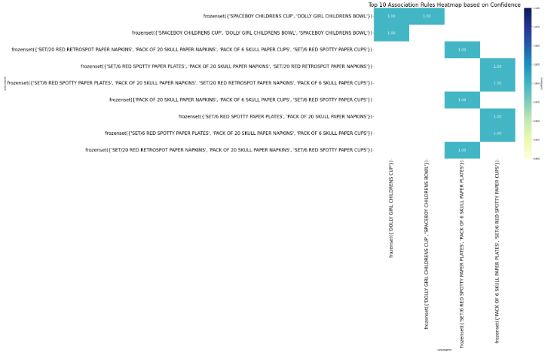

1.